Visualisation Diary  NAME:  DATE:  VISUALISATION: | 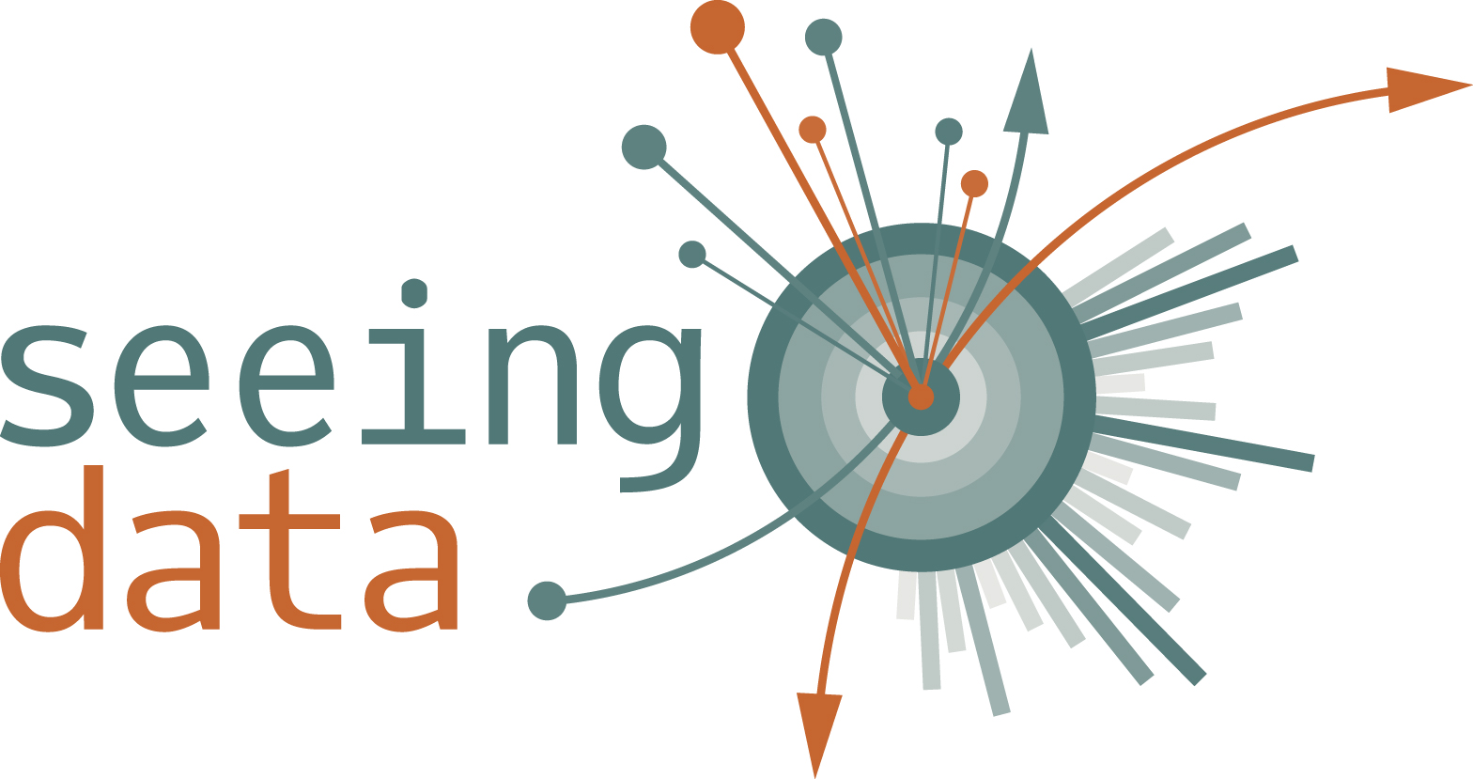
WHAT HAPPENED?
- How and where did you see the visualisation?
- Have you seen this visualisation before?
- How long did you look at the visualisation for? How quickly could you find information/answers to questions?
- What did you do first when you saw the visualisation? (e.g. Where within the visualisation did you look? Did you click on anything? Did you try to make sense of details or try to understand the general message?)

HOW DID YOU FEEL?
- Did anything surprise you about the visualisation? (e.g. where you found it; the data it conveyed; the visual elements or ‘look’)
- Did you have any particular feelings when looking? (e.g. pleasure, delight, anxiety, confusion, sadness, anger, curiosity) How strong?
- What do you like/dislike about the visualisation? (e.g. aesthetic design overall, colours, fonts, visual style, appeal).
- Did the visualisation remind you of anything? (e.g. did it look like something that wasn’t directly displayed).
- How do you feel about the subject matter?
- Do you ‘trust’ the visualisation? Why/why not?

WHAT DID YOU THINK/LEARN/REFLECT ON?
- What, if any, insights did you get from the visualisation? (e.g. What does the visualisation help you understand? Does any point stick out? What message does the visualisation communicate? Did you draw new insights about the subject matter? Were your existing perceptions reinforced or changed by the visualisation? What questions are you able/unable to answer through the visualisation? What information do you take away from the visualisation?)
- Is the visualisation easy to understand? Comment on: chart type; colours; interaction design; annotation (is more or less info needed?); layout. If you were making the visualisation, would you have done anything differently?

ANYTHING ELSE TO ADD?

